**AUDIO AND DATA TRANSFER THROUGH LIFI TECHNOLOGY**

Apurv kumar1,Anshita Yadav2,Mohd Anas3,Ranjeeta Yadav4

1,2,3,4, ABES Engineering College, Ghaziabad, Uttar Pradesh, India

ABSTRACT— Over the course of ten years, a lot of research has been done to look into other parts of the electromagnetic spectrum that might be able to move a lot of network traffic from the overcrowded radio frequency (RF) domain. OWC, or optical wireless communication, is now a viable alternative to the issues that will arise as a result of the upcoming radio frequency RF spectrum crisis, particularly in certain locations and situations. Currently, indoors, where light fidelity and visible light communication (VLC) offer effective solutions to numerous wireless communication issues, the majority of mobile data traffic is consumed. This paper examines the VLC IEEE standard, its implementations, difficulties, data modulation methods, and LiFi's newly dubbed optical wireless communication technology in particular.

Keywords- Audio And Data Transfer, Embedded System, Arduino Uno, VLC

**1. INTRODUCTION**

LEDs are used to send information in LiFi technology. It is based on optical wireless communication technology and transmits information quickly using LED light. For visible light communication, which is invisible to the human eye, the LED is quickly turned off and on. The intensity of the LiFi LED emitter remains low enough to be indistinct to the naked eye while remaining high enough to make communication simple. The intensity of the LiFi LED emitter remains high enough to facilitate simple communication while remaining low enough to be indistinct to the naked eye. The light is very protected from hacking because it can't enter the walls. However, this also restricts the reach. This is advantageous in environments, such as airplanes, thermal energy stations, and emergency clinics, that are particularly susceptible to electromagnetic impedance. This is advantageous in environments that are particularly susceptible to electromagnetic impedance, such as airplanes, thermal energy stations, and emergency clinics. While WiFi and LiFi both use radio waves to send data, LiFi uses visible light. WiFi makes use of the electromagnetic spectrum. Li-Fi has almost no capacity restrictions. While both WiFi and LiFi transmit data via radio waves, LiFi does so via visible light. WiFi utilizes electromagnetic reach. Li-Fi has essentially no restriction constraints. The evident light reach is on numerous occasions greater than the radio repeat range. The receiver receives the light signals via wireless channels. To recover the message, the collector's locator alters in response to the optical signals. Since light cannot pass through the walls, physical space can be used to protect LiFi signals. The optical signals cause the collector's locator to change to recover the message. LiFi signals can be protected in physical space because walls prevent light from passing through them.

As an optional method for data movement, VLC is a brand-new, out-of-the-box innovation that provides increased information rates and security.

**2. LITERATURE REVIEW:**

[1] This paper discusses wiring harnesses, which combine control and communication wires. The lamp, wiper, and fan assembly wiring harness were successfully replaced, resulting in a 67% weight reduction.

[2] The fact that the architecture of the new 5G cell towers is so different from that of the ones that are compatible with today's 3G and 4G mobile networks is the source of most of the concerns regarding 5G's alleged negative effects on health. Light fidelity (Li-Fi) is therefore the best option for meeting the requirements of smart cities and achieving a high data rate. Li-Fi can handle the large number of users required for Internet of Things (IoT) connectivity.

[3] In this paper, the Li-Fi has ten thousand times more control over the visible light spectrum than radio waves do. It uses visible light to transmit instead of radio waves.

[4] Sensors that monitor the human body include those that record respiration, blood pressure, and heartbeat. The PIC16F877A modifies it by converting it to digital form, which is then input into the Li-Fi module that communicates information in light form. The camera sensor's light is picked up by the receiver. The information is then visually displayed on the computer.

[5] Li-Fi also has a smaller environmental impact due to its use of the visible light spectrum. As is known, the visible light spectrum had very little effect on other organisms like plants, animals, and their ecosystems. As a result, Li-Fi is regarded as a "greener" yet more effective technology because it provides greater security, lowers power consumption, and has a lower impact on the environment.

[6] In this project, a limited-scale Li-Fi framework that can be utilized for short-range teleoperation control of a submerged vehicle is the focal point of this task. This control can be provided by a communications relay from surface-based support or by a diver working near the robot.

[7 Li-Fi is a method of transmitting data at extremely high speeds that makes use of the electromagnetic spectrum's visible light portion.

[8] With the help of readily available light sources, the system transfers data at a faster rate without the need for RF-dependent technologies. Voice-Activated Li-Fi Operated Surveillance makes use of a speech recognition algorithm and Li-Fi technology as a wireless medium to perform machine movements in response to the operator's voice.

**3. PROPOSED WORK**

Visible light is a novel method for transmitting data.

A photosensitive identifier changes the brightness of the light to send information in Li-Fi. In VLC, a light source sends and a locater gets information. The louder the voice, the brighter the LED will glow. The receiver section interprets the incoming light from the solar panel and, with the assistance of a Speaker, turns it into an audible sound signal. This strategy is getting better because Li-Fi uses multiple LEDs and information streams at the same time. Visible light is an additional method for transmitting information that enables the transmission of more data at a faster rate.

A photosensitive identifier changes the brightness of the light to send information in Li-Fi. In VLC, a light source sends and a locater gets information. The louder the voice, the brighter the LED will glow. The receiver section interprets the incoming light from the solar panel and, with the assistance of a Speaker, turns it into an audible sound signal. Because Li-Fi makes use of multiple LEDs and data streams simultaneously, this method becomes more advanced. On account of the quicker data correspondence, more information can be sent thusly.

Visible light is a novel method for transmitting data. By adjusting the brightness of the light, which is detected by a photosensitive detector, data can be transmitted in Li-Fi. In VLC, a light source sends and a locater gets information. The louder the voice, the brighter the LED will glow. The receiver section interprets the incoming light from the solar panel and, with the assistance of a Speaker, turns it into an audible sound signal. As a result, Li-Fi makes this method current by using multiple Droves and simultaneously passing multiple information streams. Observable light is an effective data transmission method that takes into account the faster transmission of additional information. By adjusting the brightness of the light, which is detected by a photosensitive detector, data can be transmitted in Li-Fi. In VLC, information is sent to a locater by a light source. The LED will glow brighter the louder the voice. With the assistance of a Speaker, the receiver section converts the solar panel's incoming light into an audible sound signal. As a result, compared to Li-Fi's simultaneous use of multiple LEDs and information streams, this method proves to be more complicated. By sending more information, this method speeds up information correspondence. a Li-Fi transceiver's fundamental operation A Drove driver receives an electrical message from it via an information device. This electrical signal is received by the photodiode in the form of light and paired data. After that, the light signal is recognized by the receiver, and the data that is sent to the output device is decoded. The positive culmination of the laser is associated with a 5-volt supply in our venture, where it is utilized to communicate sound and information to the sun-powered charger for sound sign transmission; The sound device's aux connector is connected to the ground end of the laser; The sun based controlled charger sends changes to the adequacy of the sign. For the purpose of transmitting information, the solar-powered charger's output is connected to a speaker-connected amplifier circuit. After the laser source is connected to the Arduino Uno microcontroller, the message data are converted into computerized yield for the solar-powered charger in the ranges of 1 and 0. The basic pin of the Arduino Uno is connected to the straightforward output of the sun-powered charger on the receiving end.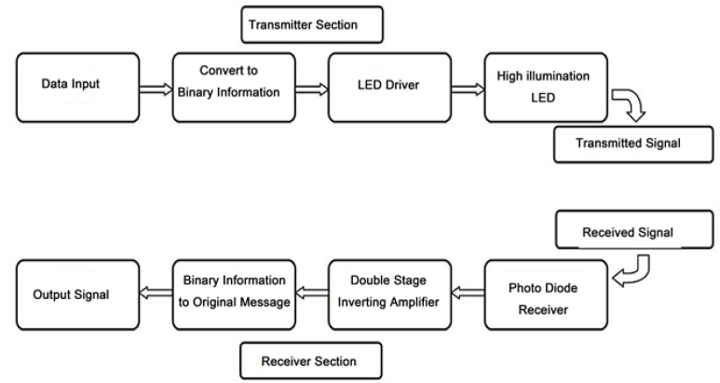

Fig 1 Block Diagram for the proposed system

**4. METHODOLOGY**

Text, images, videos, and audio signals can all be sent using Li-Fi. And also it can be used to provide internet access. The transmission of two types of data is the primary focus of this paper: text and audio waves Topologies, as well as there are many different features and variations of the data that are being sent from various setups Audio signals have been sent from one source to one output (SISO), multiple sources to multiple outputs (MIMO), and one source to one output (MISO). Using an arrangement of Arduino boards, an L.E.D., and a Silicon photo-diode were able to transmit text between two users.

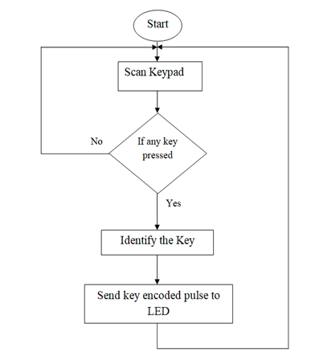

Fig 2.1 Transmitter Flow Diagram

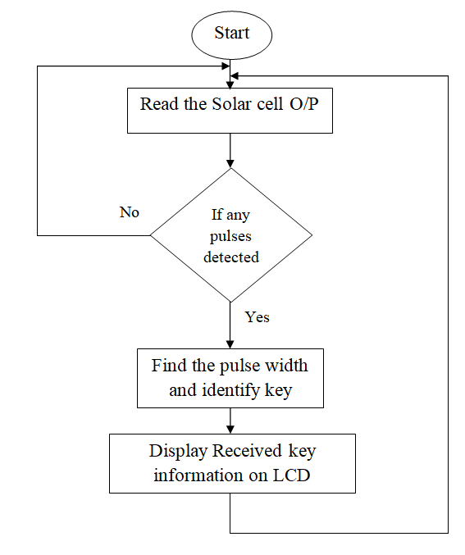

Fig 2.2 Receiver Flow Diagram

**AUDIO SEGMENT**

The audio signal was sent through the 3.5 mm jack from the phone at the transmitter end, transforming the digital signal into an analog signal. This analog signal is amplified before being sent to the breadboard-connected LED array. A power supply is also provided for the LED array. This power comes from a 9V battery that is connected to the LED array and the 3.5 mm jack. A photodetector-functioning solar panel captures this variation in light intensity. The received signal is sent to the speaker that has been pre-amplified. and records all variations. Using the same concept, an analog phone signal was substituted for text-to-speech software.

**TEXT SEGMENT**

The text transmission segment consists of three parts. The first is Arduino sends text to itself. Second, sending text between two Arduinos via infrared. Thirdly, text communication between two Arduinos via VLC.The transmission of data through LEDs is the fundamental principle of Li-Fi. When used as a light source, LED bulbs can transmit data through visible light at a constant current. LED flickering has an impact on the transmission speed as well as the flow of data. When data is transmitted, this LED turns on, and when zero is transmitted, it turns off. Variable light frequencies encode the data and strings of one and zero turn the LEDs ON and OFF, respectively. A Li-Fi trans-receiver’s fundamental operation. It transmits an electrical signal to an LED driver from an input device. The photodiode receives this electrical signal in the form of light as binary data. After that, the light signal is recognized by the receiver, and the data that is sent to the output device is decoded. In our project, laser light is used to send audio and data to the solar panel.

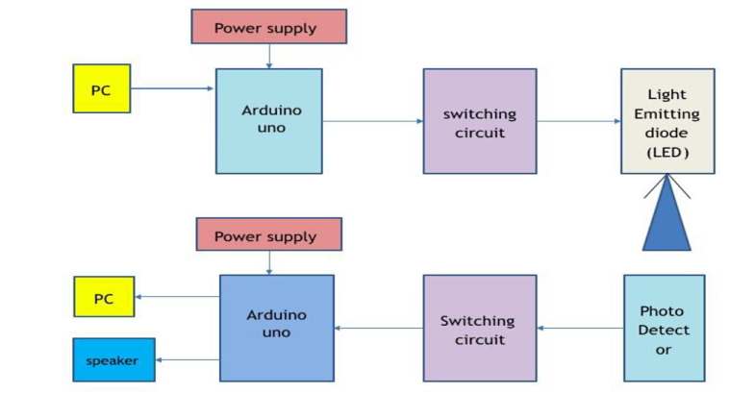

Fig 3 Block Diagram of Transmitter and Receiver Section

**5. WORKING**

The whole system consists of 3 parts. (1) Transmitter end, (2) Receiver end, (3) Transmission medium.

(1) Transmitter End: The transmitter consists of a PC with a keyboard and an Arduino. The input is given through the keyboard (example: AbCdE). The Arduino (1) converts the text into an 8-bit binary. A UART must add sync and parity bits to the data packet on the transmit side before sending it through the transmission line with a laser beam at the right time.

(2)Transmission medium: The transmission medium is nothing but air. After transmitting, the information containing the laser travels through the air and incident upon the solar panel of the receiver.

(3) Receiver End: The beneficiary contains a little daylight based charger, an Arduino, and a PC with a screen. Right when the laser shaft is event on the daylight controlled charger, it changes over the data containing the light sign into a current, and this continuous course through the Arduino (2). The bits that this Arduino converts into the corresponding alphanumeric characters are shown on the monitor of the computer. We want this to happen. At the transmitter end, the audio signal was sent through a smartphone's 3.5 mm jack, which also provided the signal. Both the phone's audio input and the 3.5mm audio jack undergo analog conversion. A 3.5mm sound jack consistently has three outcome lines: ground, left, and right The left and right audio output signals are connected to the negative terminals of the 9V battery. The resistors that are connected in series with the LED array are grounded by the positive of the 9V array, and the 3.5mm jack is grounded by the negative of the LED array that is connected to a breadboard. The changes happen quickly and are hard to see with the naked eye.

**6 HARDWARE IMPLEMENTATION & CIRCUIT** 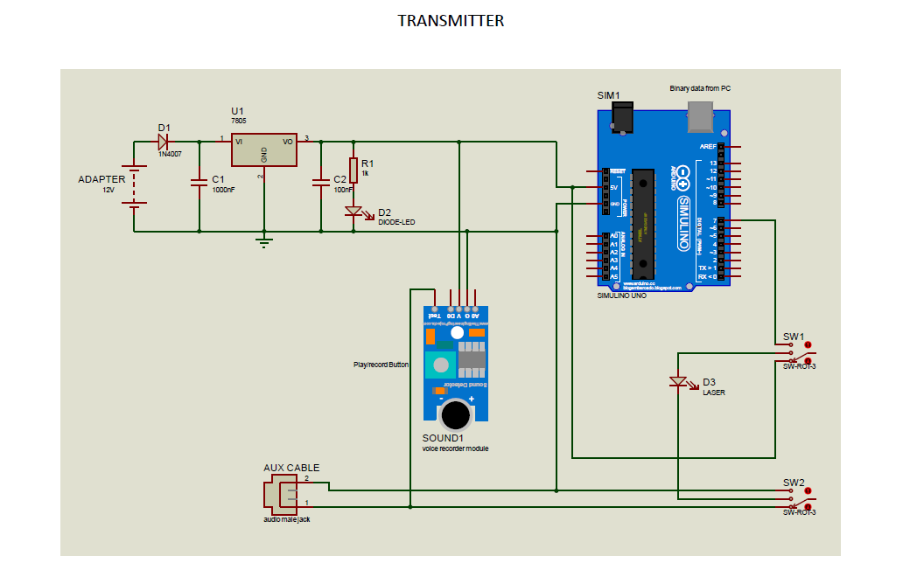

Fig 4.1Circuit Diagram of Transmitter Section

For Audio signal transmission, the positive end of the laser is connected to a 5v supply, the ground of the laser is connected to an aux cable to an audio device, the signal amplitude fluctuations are transmitted to the solar panel, the solar panel output is connected to amplifier circuit i.e connected to the speaker. At the sending end, Arduino-1 is used to convert the alphanumeric characters into 8-bit ASCII code.

For the code, we have to do the followings: Take the characters as input and Convert the characters into ASCII code of which the start bit is 1 The delay is set to 10ms between two consecutive bits Set the delay of 100ms between two consecutive Bytes. Then Upload the code. The phone's built-in digital-to-analog converter is used to transfer the digital music file to the audio jack, which is located here. The audio jack is connected in series in the transmitter circuit, which is powered by a power supply circuit. If it starts playing a song, it will send the data through the LEDs, but it doesn't have the speaker circuit hooked up yet, so it can't tell if it's being sent because the LEDs change too quickly for the eye to see.

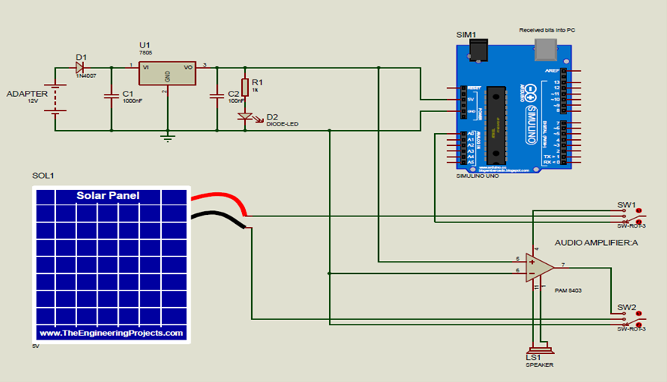

Fig 4.2 Circuit Diagram Of Receiver Section

For Data transmission, the laser source is connected to Arduino uno microcontroller, and the text data is converted to digital output in 1, 0 forms to the solar panel. At receiving side solar panel the analog output of Arduino Uno, then the output character data is taken out via serial monitor. Laser light is sent to the solar panel and the solar panel now receives the data. The solar panel is connected with the A0 pin and ground. After checking the value of the solar panel using built-in “AnalogReadSignal” both when there is no light on the laser, and when there is light on the laser. We then set the THRESHOLD Value for the solar panel by examining the value from “AnalogReadSignal”. In setup, we consider the solar in A0 as input and fix the Serial. begin to 9600. Then we take the reading from the solar pin. If the Reading from the solar in is greater than the threshold, then we consider it to be ‘1’, otherwise it is considered as ‘0’.

**7. RESULT**

The results obtained from the research work are been discussed as follows.

**A. Audio Transmission**

We were able to transmit audio, in this case, music from a smartphone, by connecting three three-volt LEDs in series with a 220-ohm resistor for 0.5 feet. The music signal can be heard for one foot if there are no outside light interferences. A summary of the model is provided in Figures 5 and 6.

Step 1: When the audio is received initially through a 3.5mm jack, the LEDs begin to blink.

Step 2: When the LED blink it can send the data to a solar panel in front of them that picks up the changes in light and sends an amplified audio signal to the receiver.

**B. Text Transmission**

Utilizing a Li-fi module remembered for the Arduino Nano microcontroller and a text-to-discourse text-to-discourse sequential to-USB converter, the text was communicated between two workstations. The text can be sent here with up to 100 characters if there is no obstruction three feet away from the phone. The model as a whole is shown in Figure 7.

Step 1: On the PC that is sending, an information message is at first placed into the Arduino IDE. " The message begins, "Good Morning, and Welcome to ABES Engineering College."

Step 2: When the Arduino IDE program is executed on the receiving PC, the "RUNNING" message is displayed on the screen. As can be seen in Fig., after the transmitter has received the input message, we now receive an audio and text message that reads "Good Morning Welcome to ABES Engineering College." 8.

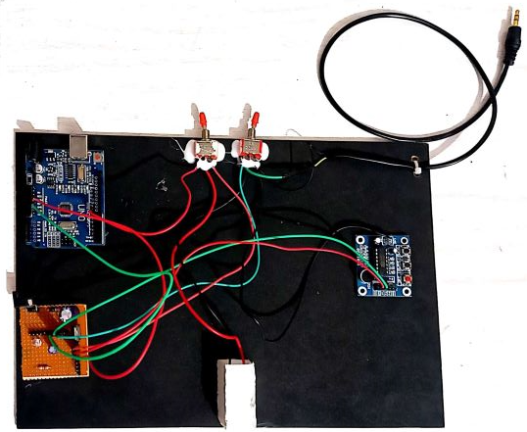

Fig 5 Transmitter Section Model Overview

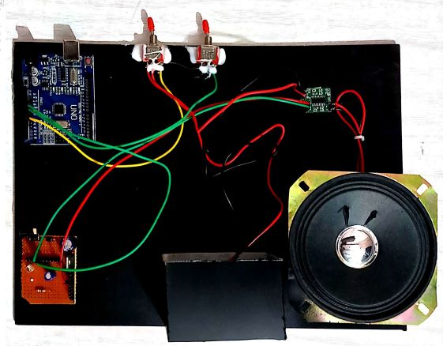

Fig 6 Receiver Section Model Overview

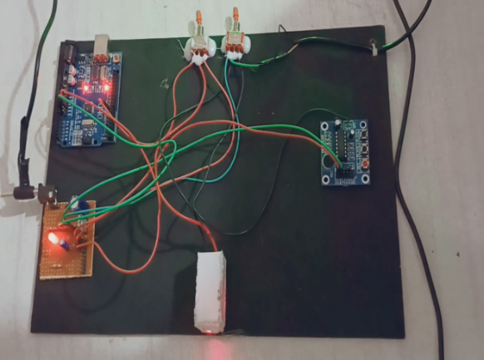

Fig 7 Text Transmission Model Overview

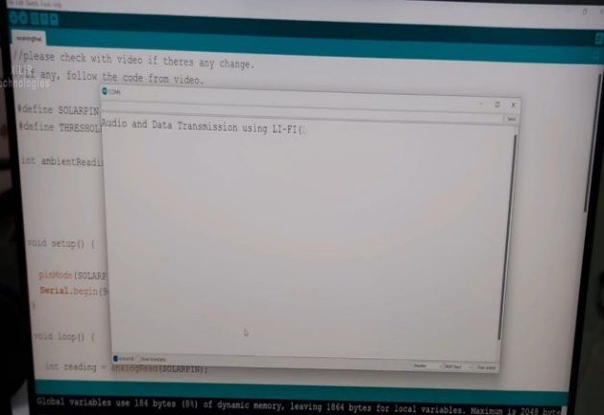

Fig. 8: Message is received by the receiver and played.

**8 . CONCLUSION**

Every light bulb can serve as a Wi-Fi hotspot for wireless data transmission if this technology is implemented, and our future will be cleaner, greener, safer, and brighter. Li-Fi is currently receiving a lot of attention due to the possibility of providing a genuine and highly effective alternative to radio-based wireless. The airwaves are becoming increasingly congested as a result of the increasing number of individuals and devices. using wireless internet, making it increasingly challenging to obtain a fast, dependable signal. This could help with problems like a lack of radio-frequency bandwidth and make the internet possible in places like airplanes and hospitals where traditional radio-based wireless is prohibited. In this paper, a continuous sound transmission model is made with commercial LEDs; It is anticipated that commercial LED lamps will allow transmitting information over long distances. High-quality audio can be transmitted over a one-millimeter distance with the addition of a Focusing lens between transmitter and receiver, International Journal of Pure and Applied Mathematics, Special Issue 184.

**9. FUTURE SCOPE**

Li-Fi is a brand-new technology with a lot of promise. There is a lot of room for research in this area. In this area, a lot of scientists are already doing a lot of research. Li-Fi's future lies in Gi-Fi. Wireless communication that transmits data over one billion bits per second (gigabit) is referred to as "gigabit wireless" or "Gi-Fi." By using Li-Fi, parallelism can save energy. In the not-too-distant future, we might be able to put in place an LED array next to a motorway.

**10. REFERENCES**

1. T.Komine and M. Nakagawa, ”Fundamental analysis for visible light communication systems using LED Lights, ”IEEE Trans. Consumer Electronics, vol. 59, no.1, Feb 2004.

2. S. Schmid, G. Corbellini, S. Mangold, and T.R. Gross, “Led-to-led visible light communication networks, ” in Proceedings of the Fourteenth ACM international symposium on Mobile ad hoc Networking and computing. ACM, 2013, pp. 1–10.

3. Online International, 2016: "High sensitivity universal Lifi receiver for enhanced data communication," by Zashi P. Choudhari and Satish R.Devane Conf. on Green Engineering and Technologies (ICGET) ISBN 978-1-5090-4556-3/16/31.00 IEEE

4. S. Rajagopal, R. D. Roberts, and S.-K. Lim, “Ieee 802.15. 7 visible light communication: modulation schemes and dimming support, ” Communications Magazine, IEEE, vol. 50, no. 3, pp. 72–82, 2012.

5. Mesleh, R., Elgala H.and Haas, H., ―Indoor Optical Wireless Communication: Potential and State-of-the-Art, ‖ IEEE Commun. Mag. 49, 56–62 (Sept. 2011).ISSN: 0163-6804.

6. Rohan Kapoor, Allesandro Gardi, Roberto Sabatini “A Multistatic Ultrasonic Navigation System for GNSS-Denied Environment AIAA Scitech 2019 Forum, 2019. pp.1930.

7. D. Andrade, J. P. Gomes, and P. S. André, "Execution of a Noticeable Light Correspondence Connection: Smartphone Li-Fi DOI: "2019," 10.9790/2834-1703015258 www.iosrjournals.org 58 | Page Detection.

8. M. D. Soltani and Associates, Bidirectional optical spatial modulation for mobile users: Towards a Practical LiFi System Design," IEEE Selected Areas in Communications, vol. 37, no. 9, pp. 2069- 2086, 2019.

9. D. Ramananda, A. M. Sequeira, S. R. Raikar, and C. K. Shanbhag's "Design and Implementation of LiFi Communicatio system" in the IOP Conference Series: 2019, vol. 594, no. 1, Materials Science and Engineering 1, p. 012041: IOP's publishing

10. H. Haas and co., Introduction to the concepts and difficulties of indoor networking in LiFi," Journal of Optical Communications and Networking, vol. 12, no. 2, pp. A190-A203, 2020.

11. The ns-3 network simulator," by G. F. Riley and T. R. Henderson, in Modeling and tools for network simulation: pp. Springer, 2010. 15-34.

12. Sapna Mamidkar, Rasmiranjan Samantray “A Survey on Li-Fi Technology and Its Applications” Archived from International Journal of Science and Research Volume 7 Issue 7 pp;1388-1392 July 2018.

13."A performance study of various mobility speeds on AODV routing protocol in homogeneous and heterogeneous MANET," by Z. Ismail and R. Hassan, is published in IEEE The Seventeenth Asia Pacific Gathering on Correspondences, 2011 637-642.

14. Li-Fi (Light Loyalty) - An Outline to Future Remote Innovation in the Field of Information Correspondence," by Gurpinder Singh, published in November 2015.

15. Mrs. M. Prathibha, M. Sharmila, M. Shrin Shifana, V.Theebica, and V. Sangeethapriya's audio transmission over a life system in April 2018.